Calendar Guide for VHL Alliance (VHLA)

Calendar Reminder 2

Core Calendar Reminder Requirements 2

Email Reminder Plugin 2

Create Calendar Reminder 4

Configure Network Solutions to Check for Calendar Reminders 6

Issue Tracking 7

Calendar Reminder Enhancements 8

VHLA Admin for Calendar Reminder (Email Reminder Plugin) 8

Update Scan List 8

Update Reminder Email Message 8

Add a Name Field 8

User Searchs for Calendar Reminders 8

A User Deletes a Calendar Reminder 9

A User Reschedule a Calendar Reminder 9

Figure 1: Email Reminder Plugin 3

Figure 2: Create Email Reminder 5

# Calendar Reminder

## Core Calendar Reminder Requirements

The VHLA Requirements are as following:

* Requirement 1: “The user sets reminders for the selected scans.”
* Requirement 2: “The user receives the reminder (by email).”
* Requirement 3: “VHLA captures who is using the reminder tool.”

## Email Reminder Plugin

As per the Email Reminder plugin documentation (<https://wordpress.org/plugins/email-reminder/>): “This plugin allows you to send email reminders to any email address on the date and time that you specify. So, basically, all you have to do is to enter your reminder, enter the email address you'd like to send the reminder to, and when you'd like the reminder to be sent.”

The installation of the Email Reminder assists VHLA in two ways:

* The Email Reminder plugin provides a Schedule Reminder and Sent Reminders list. These lists would satisfy Requirement 3 of the [Core Calendar Reminder Requirements](#_Core_Calendar_Reminder_2), “VHLA captures who is using the reminder tool.”
* The Email Reminder plugin provides a baseline of code and functionality to the VHLA developer to assist in the creation of the [Create Calendar Reminder](#_Create_Calendar_Reminder).

#### Installation Steps of the Email Reminder Plugin:

Install and activate the Email Reminder plugin (<https://wordpress.org/plugins/email-reminder/installation/>). The Email Reminder plugin is installed in the WordPress plugin directory in the email-reminder folder: /wp-content/plugins/email-reminder. After installation and activation, the Email Reminder plugin will be available in the Dashboard section or the root of the VHLA Wordpress Admin console.

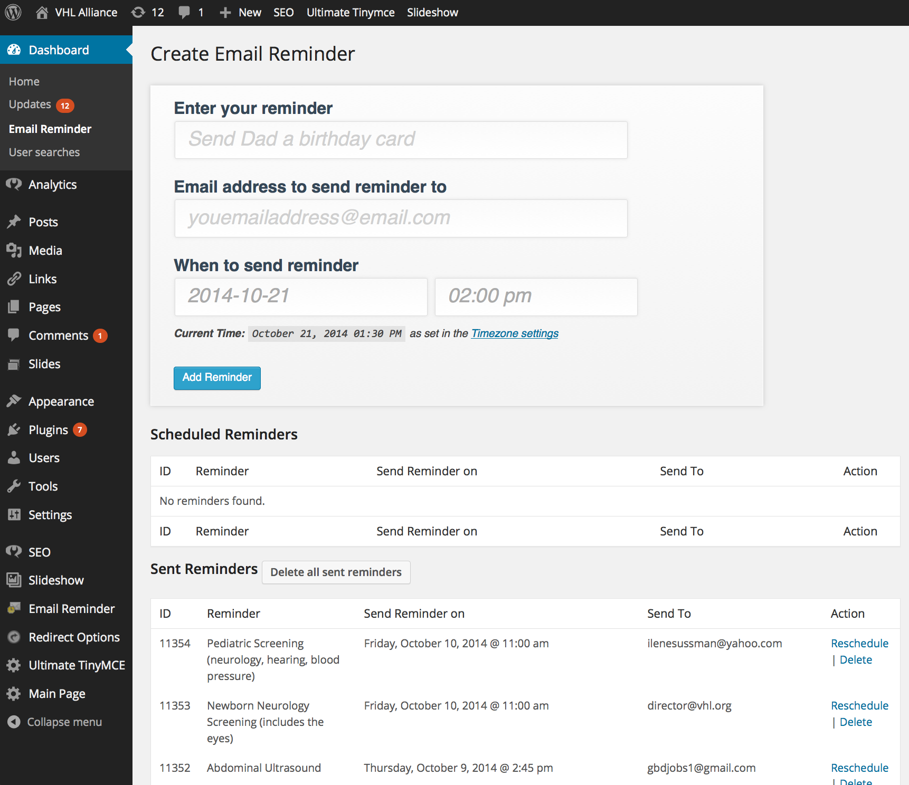

Figure 1: Email Reminder Plugin

## Create Calendar Reminder

As per design, the Create Calendar Reminder meets [Core Calendar Reminder Requirements](#_Core_Calendar_Reminder_1) 1: “The user sets reminders for the selected scans.” and Requirement 2: “The user receives the reminder (by email).”

#### Implementation Steps of the Create Calendar Reminder:

1. Copy and paste the Email Reminder plugin code to the following directory: /wp-content/plugins/email\_reminder\_vhl.
2. Create the WordPress page for “Reminder for Annual VHL Screening”. The Reminder for Annual VHL Screening page can be found here: <http://www.vhl.org/wordpress/patients-caregivers/living-with-vhl/diagnosis-and-treatment/screening-and-testing-protocols/suggested-screening-guidelines/reminder-annual-vhl-screening/>
3. Modify page.php to launch the Create Calendar Reminder within the Reminder for Annual VHL Screening page.
4. Modify Create Calendar Reminder to work within the vhl web application. Currently, the Email Reminder plugin is only designed to work in the Wordpress Admin console.
5. Remove the “Enter your reminder” textbox and replace with a drop down of the scan names.
6. Update the Create Calendar Reminder code to generate the following email message:

“Good Day!

You have scheduled a reminder for [scan name].

It is that time again. This is a friendly reminder about scheduling your annual VHL screening. Screening Guidelines can be found at: [www.vhl.org/patients-caregivers/living-with-vhl/diagnosis-and-treatment/screening-and-testing-protocols/suggested-screening-guidelines/](http://www.vhl.org/patients-caregivers/living-with-vhl/diagnosis-and-treatment/screening-and-testing-protocols/suggested-screening-guidelines/" \t "_blank).

After your screening, please remember to update your profile on VHLA’s Cancer in Our Genes International Patient Databank (CGIP) at [www.vhl.org/databank](http://www.vhl.org/databank" \t "_blank). “

1. Remove the Schedule Reminder and Sent Reminders lists.

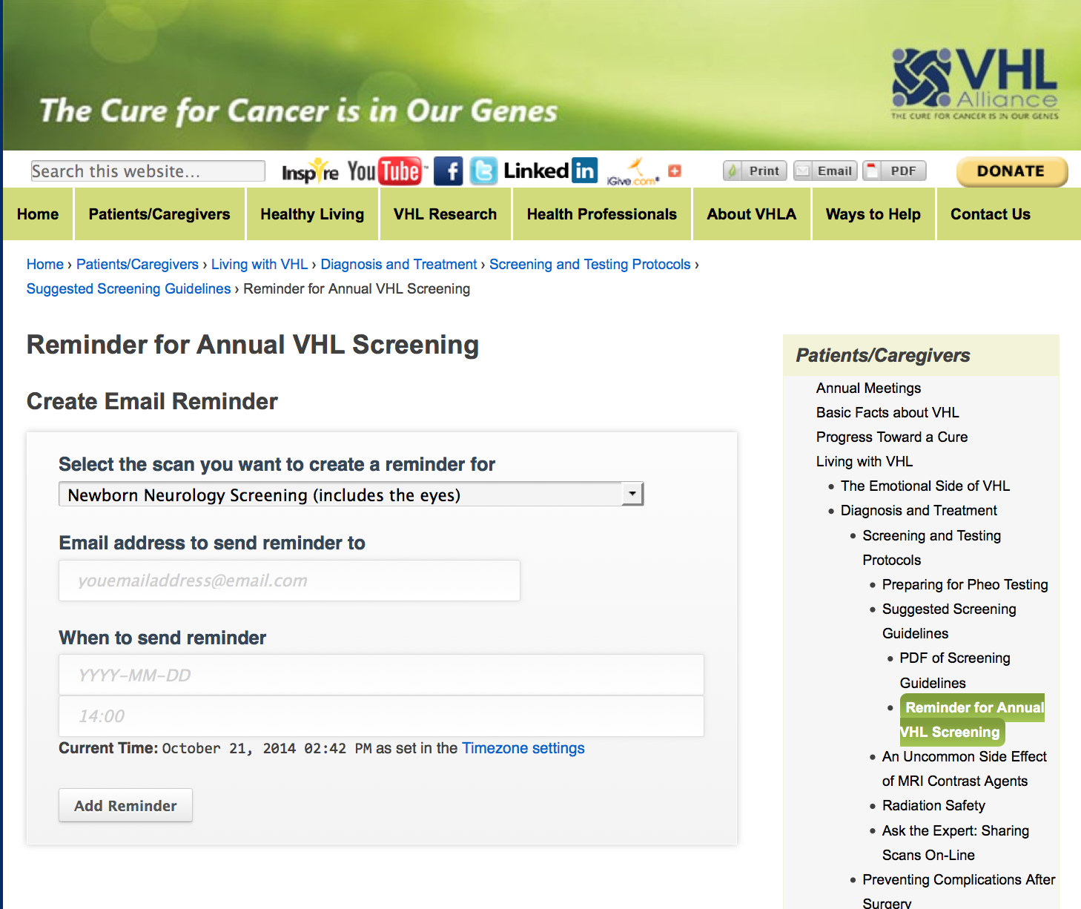

Figure 2: Create Email Reminder

# Configure Network Solutions to Check for Calendar Reminders

WordPress cron scheduler (WP Cron) periodically checks for reminders to be sent. Unfortunately, WP Cron is not a real cron scheduler like the one found in Linux operating systems which can run commands and scripts on time. WP Cron depends on users visiting your web site in order to trigger WP Cron. This means that by default, reminders won't always get sent on the exact time you want. This is most noticeable on sites with very low traffic. But, there is a way to work around this problem by leveraging real Linux cron instead as expressed in the following site (<http://pogidude.com/2011/use-linux-cron-to-trigger-wordpress-cron-scheduler/>).

Here are the steps:

1. Log onto Network Solutions (<http://www.networksolutions.com/>).
2. Select My Hosting Packages 🡪 Hosting Tools 🡪 Scheduled Tasks Manager.
3. Add a Task.
4. Scheduled Task:
   1. Task Name: Email Reminder.
   2. Program File: wget -O /dev/null <http://www.vhl.org/wordpress/wp-cron.php>
   3. Frequency: every hour at 00,30 min(s).

# Issue Tracking

1. Issue: Cannot visit the Reminder for Annual VHL Screening more than once.

Solution: It appears this is a problem with the draft/preview mode in WordPress as oppose to the page itself. I published the page in WordPress. One can know return to the page without an error.

1. Issue: Email hosts may interpret the Calendar Reminder as spam.

Example: Ilene did not receive an email with her [director@vhl.org](mailto:director@vhl.org) account.

Solution: I use the WordPress function antispambot. This Converts email addresses characters to [HTML entities](http://en.wikipedia.org/wiki/HTML_entities) to block spam bots.

<http://codex.wordpress.org/Function_Reference/antispambot>

1. Issue: From November 4th email, Ilene requests the drop down scan option “Test for fractionated metanephrines (blood test or 24 hour urine test)” changed to “Test for pheochromocytoma (blood test or 24 hour urine test)”.

Solution: Updated ereminder-page.php.

# Calendar Reminder Enhancements

The Calendar Reminder Enhancements provide an enriched experience for both VHLA administrators and users. The Calendar Reminder Enhancements has no effect on the [Core Calendar Reminder Requirements](#_Core_Calendar_Reminder_3). The Core Calendar Reminder Requirements are met by the implementing the [Email Reminder plugin](#_Email_Reminder_Plugin_1) and [Create Calendar Reminder](#_Create_Calendar_Reminder_1).

## VHLA Admin for Calendar Reminder (Email Reminder Plugin)

Add features to the [Email Reminder plugin](#_Email_Reminder_Plugin) that are only available to a user with admin WordPress privileges.

### Update Scan List

Allow a user to update the [Create Calendar Reminder](#_Create_Calendar_Reminder_1) scan list without a developer’s assistance. Currently the scan list is hardcoded in email\_reminder\_vhl/views/ereminder-page.php.

### Update Reminder Email Message

Allow a user to update the [Create Calendar Reminder](#_Create_Calendar_Reminder_1) email message without a developer’s assistance. Currently the email message is hardcoded in email\_reminder\_vhl/includes/classes/PDER.php.

## Add a Name Field

One can only identify who is using the [Create Calendar Reminder](#_Create_Calendar_Reminder_1) by entered email address. Add a name field (or first and last name fields) to the Create Calendar Reminder and [Email Reminder plugin](#_Email_Reminder_Plugin).

#### Add Name Field to Create Calendar Reminder

Add a name field (or first and last name fields) to the Create Calendar Reminder.

#### Add Name Field to Email Reminder plugin

Add a name field (or first and last name fields) to the Create Calendar Reminder. This includes the either or both the Create Reminder field or just the Schedule Reminder and Sent Reminders list.

#### Display List of Names that Use the Create Calendar Reminder

Display a list of users who use the Create Calendar Reminder.

## User Searchs for Calendar Reminders

Add a WordPress page that provides a user to search for their Calendar Reminders by an email address or name.

### A User Deletes a Calendar Reminder

A user can delete a Calendar Reminder from the results list.

### A User Reschedule a Calendar Reminder

A user can reschedule a Calendar Reminder from the results list.